Sunday | Monday | Tuesday | Wednesday |  | Thursday | Friday | Saturday
 |  |  |  |  |  | 1  Diwali (Hindu) | 2
3  Daylight Saving Time Ends | 4 | 5 |  | 6 | 7 | 8 | 9
10 | 11  Veterans Day  Remembrance Day (Canada) | 12 |  | 13 | 14 | 15 | 16
17 | 18 | 19 |  | 20 | 21 | 22 | 23
24 | 25 | 26 |  | 27 | 28  Thanksgiving Day (US) | 29 | 30

  Ellen’s Place |  |  |  |  | Let’s Play  CORNHOLE!  Learn a fun game anyone can play!  2:30pm  In the Community Room | Alex Groat  Building Program Director  585-546-8439  ext 4701  agroat@  episcopalseniorlife  .org
 | Fit & Flexible Class@ 10am the 2nd Floor Studio  COFFEE TALK  2pm Kitchen |  | Walking Club  Main Entrance @ 10am  Coffee Hour 11am  In the Kitchen Café  Meal Pick-up after 4pm | 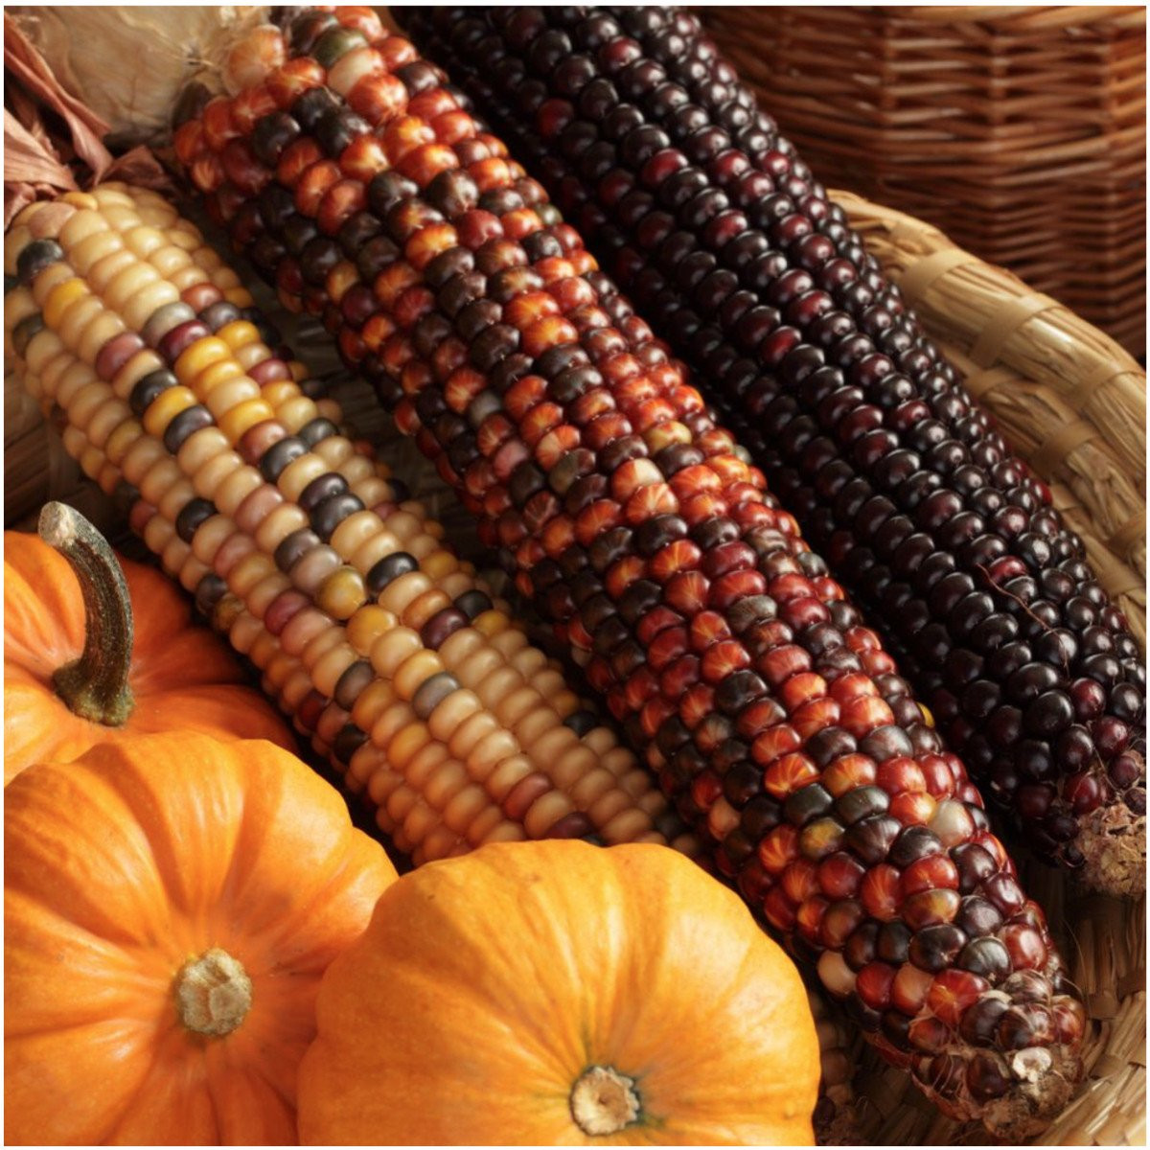 | PING PONG  for beginners!  Join us on the  3rd floor A wing  at 2pm | 
Mass at  St. Cecilia Church  Every Sunday  8am | Veterans  We Thank You  Breakfast  Check the 1st floor bulletin board for details or contact Julie! |  | Walking Club  Main Entrance @ 10am  Coffee Hour 11am  In the Kitchen Cafe  Meal Pick-up after 4pm | What’s the Emergency Maintenance Number?    585-319-2512 | Let’s Play  CORNHOLE!  Learn a fun game anyone can play!  2:30pm  In the Community Room | INCLUDEPICTURE "cid:image003.jpg@01D7AE0F.89BA2820" \* MERGEFORMATINET INCLUDEPICTURE "cid:image003.jpg@01D7AE0F.89BA2820" \* MERGEFORMATINET INCLUDEPICTURE "cid:image003.jpg@01D7AE0F.89BA2820" \* MERGEFORMATINET INCLUDEPICTURE "cid:image003.jpg@01D7AE0F.89BA2820" \* MERGEFORMATINET INCLUDEPICTURE "cid:image003.jpg@01D7AE0F.89BA2820" \* MERGEFORMATINET INCLUDEPICTURE "cid:image003.jpg@01D7AE0F.89BA2820" \* MERGEFORMATINET INCLUDEPICTURE "cid:image003.jpg@01D7AE0F.89BA2820" \* MERGEFORMATINET INCLUDEPICTURE "cid:image003.jpg@01D7AE0F.89BA2820" \* MERGEFORMATINET INCLUDEPICTURE "cid:image003.jpg@01D7AE0F.89BA2820" \* MERGEFORMATINET INCLUDEPICTURE "cid:image003.jpg@01D7AE0F.89BA2820" \* MERGEFORMATINET INCLUDEPICTURE "cid:image003.jpg@01D7AE0F.89BA2820" \* MERGEFORMATINET INCLUDEPICTURE "cid:image003.jpg@01D7AE0F.89BA2820" \* MERGEFORMATINET INCLUDEPICTURE "cid:image003.jpg@01D7AE0F.89BA2820" \* MERGEFORMATINET INCLUDEPICTURE "cid:image003.jpg@01D7AE0F.89BA2820" \* MERGEFORMATINET INCLUDEPICTURE "cid:image003.jpg@01D7AE0F.89BA2820" \* MERGEFORMATINET INCLUDEPICTURE "cid:image003.jpg@01D7AE0F.89BA2820" \* MERGEFORMATINET INCLUDEPICTURE "cid:image003.jpg@01D7AE0F.89BA2820" \* MERGEFORMATINET INCLUDEPICTURE "cid:image003.jpg@01D7AE0F.89BA2820" \* MERGEFORMATINET INCLUDEPICTURE "cid:image003.jpg@01D7AE0F.89BA2820" \* MERGEFORMATINET INCLUDEPICTURE "cid:image003.jpg@01D7AE0F.89BA2820" \* MERGEFORMATINET INCLUDEPICTURE "cid:image003.jpg@01D7AE0F.89BA2820" \* MERGEFORMATINET INCLUDEPICTURE "cid:image003.jpg@01D7AE0F.89BA2820" \* MERGEFORMATINET 
Mass at  St. Cecilia Church  Every Sunday  8am | Fit & Flexible Class@ 10am the 2nd Floor Studio  COFFEE TALK  2pm Kitchen |  | Walking Club  10am  Art Class @2pm  Learn about an artist and try their style! Anyone can do it!Sign up on the 1st floor Bboard!  Meal Pick-up after 4pm | Take a walk!  It’s great for your heart AND your bones!  | PING PONG  for beginners!  Join us on the  3rd floor A wing  at 2pm | 
Mass at  St. Cecilia Church  Every Sunday  8am | Fit & Flexible Class@ 10am the 2nd Floor Studio  COFFEE TALK  2pm Kitchen | How do YOU   | Walking Club  Main Entrance @ 10am  Coffee Hour 11am  In the Kitchen Cafe  Meal Pick-up after 4pm |  | Let’s Play  CORNHOLE!  Learn a fun game anyone can play!  2:30pm  In the Community Room | Julie Montgomery  Wellness Coordinator  585-415-9507  jmontgomery@  episcopalseniorlife  .org
ESLC ELLEN’S PLACE 65 BROWER ROAD ROCHESTER NEW YORK 14622

