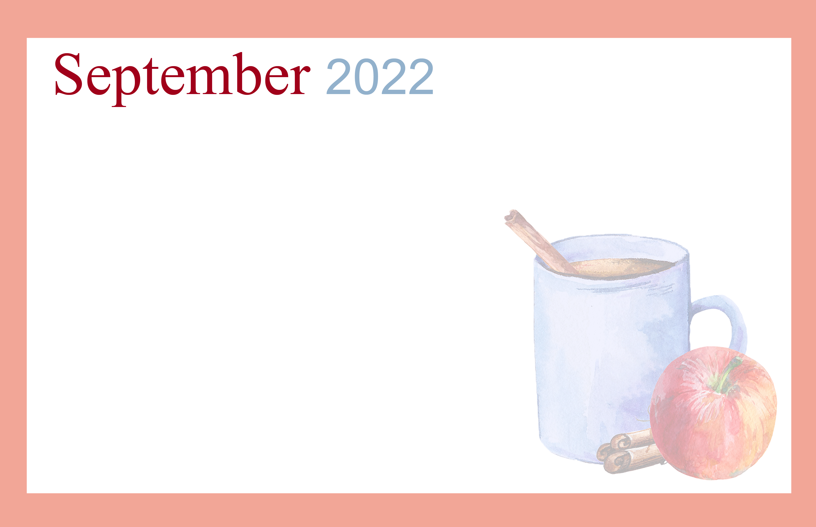 |  |  |  | 11:00am MITE Exercise Class w/ Bonnie – C  1:30pm Movie Matinee – 1L | 10:30am Cardio Drumming with Bonnie – C  1:30pm Euchre  w/ Residents – 2L  3:00pm Happy Hour w/ Bonnie - Patio | Puzzle Packets Available at The Desk  1:30pm Bingo w/  Barb K. – C  6:15pm Bingo w/  Barb K. - C
Take a walk with a Friend  1:30pm Bingo w/  Barb K. – C  6:15pm Bingo w/  Barb K. - C | Work on the puzzle in the first floor lounge  Take a Walk, Write a Letter, or Call a Friend | 10:15am Art for The Young at Heart – Café  3:00pm Seated Yoga w/ Bonnie - C | Hairdresser Day!  Afternoon Medical Transportation  1:30pm Table Top Bowling - C  3:00pm Worship Service w/  Patti – C  6:15pm Bingo w/ Jenna &  Marc - C | 11:30am BBQ Lunch on The Patio & Dining Room  3:00pm MITE Exercise Class w/ Bonnie - C | 10:30am Cardio Drumming with Bonnie – C  1:30pm Euchre  w/ Residents – 2L  3:00pm Happy Hour w/ Bonnie - Patio | Puzzle Packets Available at The Desk  1:30pm Stretch & Tone w/ Debbie – C  2:15pm Table Top Bowling w/ Debbie - C
Take a walk with a Friend  1:30pm Bingo w/  Barb K. – C  6:15pm Bingo w/  Barb K. - C | 10:30am MITE Exercise  Class w/ Bonnie – C  2:30pm Wii Bowling w/  Bonnie – C  4:00pm Dinner Time Trivia w/  Bonnie –1L | 10:00am Brain Games w/ Staff – 1L  1:30pm Resident Council – C  3:00pm Seated Yoga w/ Bonnie - C | Hairdresser Day!  Afternoon Medical Transportation  2:00pm Music with The Rhythm Aces - Patio  3:00pm Worship Service & Communion w/ Deven – C  6:15pm Bingo w/ Jenna &  Marc - C | 11:45am Order In Lunch: Wegmans Subs ( Sign up at the Desk )  3:00pm MITE Exercise Class w/ Bonnie - C | Enjoy Some Sunshine on the Patio  1:30pm Euchre w/  Residents – 2L  3:00pm Meet & Greet with Debbie & Happy Hour – Café | Puzzle Packets Available at The Desk  1:30pm Bingo w/  Barb K. – C  6:15pm Bingo w/  Barb K. - C
Take a walk with a Friend  1:30pm Bingo w/  Barb K. – C  6:15pm Bingo w/  Barb K. - C | 1:30pm Short Story Reading  & Discussion Group w/ Barb  M. – 2L | 10:00am Brain Games w/ Bonnie – 1L  1:30pm Movie Matinee – 1L | Hairdresser Day!  Afternoon Medical Transportation  1:30pm Mini Golf – 2L  3:00pm Worship Service w/  Patti – C  6:15pm Bingo w/ Jenna &  Marc - C | 10:30am Tabletop Bowling w/ Bonnie - C  3:00pm MITE Exercise Class w/ Bonnie - C | 10:30am Cardio Drumming with Bonnie – C  1:30pm Euchre  w/ Residents – 2L  3:00pm Happy Hour w/ Bonnie - Patio | Puzzle Packets Available at The Desk  1:30pm Stretch & Tone w/ Debbie – C  2:15pm Brain Games w/ Debbie - C
Take a walk with a Friend  1:30pm Bingo w/  Barb K. – C  6:15pm Bingo w/  Barb K. - C | 11:30am Out to Lunch  Adelita’s Mexican  Restaurant  (Sign up at The Desk)  1:30pm Movie Matinee – 1L  4:00pm Dinner Time Trivia w/  Bonnie –1L | 10:00am Brain Games w/ Staff – 1L  1:30pm Food Committee w/ Justin – C  3:00pm Seated Yoga w/ Bonnie - C | Hairdresser Day!  Afternoon Medical Transportation  1:30pm Explore Broadway with Broadway Bob -C  3:00pm Worship Service & Communion w/ Deven – C  6:15pm Bingo w/ Jenna &  Marc - C | 11:00am Corn Hole Game w/ Bonnie - Patio  1:30pm Reminisce & Discussion Group with Barb M. – 2L  3:00pm MITE Exercise w/ Bonnie - C | 10:30am Cardio Drumming with Bonnie – C  1:30pm Euchre  w/ Residents – 2L  2:30pm Birthday Bash & Happy Hour w/ Bonnie - Patio |   1st Floor Lounge – 1L  2nd Floor lounge – 2L  Community Room - C
ASHLEY WOODS CALENDAR OF EVENTS ARE SUBJECT TO CHANGE; ANY QUESTIONS CONTACT Bonnie Gregoire X 6504
Sunday | Monday | Tuesday | Wednesday | Thursday | Friday | Saturday
 |  |  |  | 1 | 2 | 3
4 | 5  Labor Day | 6 | 7 | 8 | 9 | 10
11  Grandparents Day | 12 | 13 | 14 | 15 | 16 | 17  Oktoberfest Begins
18 | 19 | 20 | 21 | 22  Autumn Begins | 23 | 24
25  Rosh Hashanah Begins | 26 | 27 | 28 | 29 | 30

