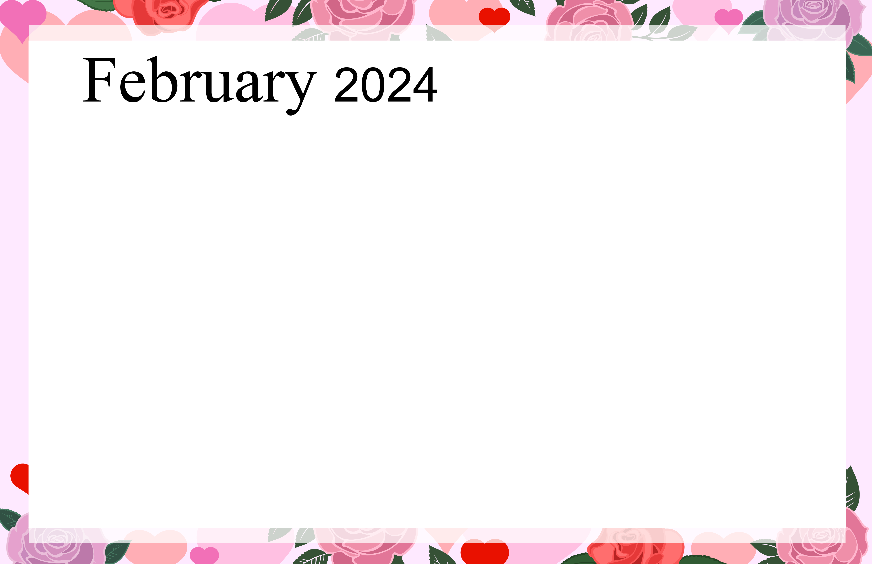  Ashley Woods |  |  |  | Hairdresser Day!  10:30am Robinson Crusoe Day w/ Debbie 1L  1:30pm Wii Bowling w/ Bonnie - C  3:00pm MITE Exercise Class w/ Bonnie  4:00pm Brain Games w/ Bonnie 1L | Medical Transportation  10:30am Cardio Drumming w/ Bonnie – C  1:30pm Live Music w/  Mike Kornrich - C  3:00pm Happy Hour w/ Bonnie – Café | Puzzle Packets Available in The First Floor Lounge  11:00am – 11:30am Micro Library Open – Café  1:00pm Chair Dancing & Team Family Feud w/ Rebecca – C  3:00pm Bingo w/ Barb K. - Cafe
Write a Letter or  Call a Friend | 10:30am MITE Exercise  Class w/ Bonnie – C  1:30pm Monarch Day Documentary  and Discussion w/Debbie 1L  3:00pm Monarch Craft w/Debbie  Cafe | 10:00am- Queens Day Trivia w/Debbie 1L  1:30pm Stretch & Flow with  Bonnie – C  3:00pm Armchair Travel with Beth: Food Americana - C | Medical Transportation  10:00am – 11:00am Micro Library Open – Café  1:30pm Heart Collage w/Debbie Cafe  2:30pm Rosary & Catholic Communion w/ Kathy – C  6:00pm Bingo w/ Barb R. – Café | Hairdresser Day!  10:30am Jules Verne’s Birthday w/Debbie 1L  1:30pm Remembering Love Songs with Bonnie – 1L  3:00pm MITE Exercise Class with Bonnie – C  4:00pm Brain Games w/ Bonnie 1L | Medical Transportation  1:45pm Word Games  w/ Debbie - 1L  3:00pm Happy Hour w/ Debbie – Café | Puzzle Packets Available in  The First Floor Lounge  11:00am – 11:30am Micro Library Open – Café  1:00pm Seated Yoga Followed by Wheel of Fortune  w/ Rebecca – C  3:00pm Bingo w/ Barb K. - Cafe
Happy Birthday Barb R.!  Watch a Movie or Read a Book  6:30pm Superbowl LVIII   | 1:30pm Live Music with Tom &  Peg - C  3:00pm Lost Penny Day  w/Debbie 1L | 10:00am Travel to Mardi Gras w/Debbie 1L  1:30pm Resident Council & Word Games to Follow – C  3:00pm Stretch & Flow  w/ Bonnie – C  4:00pm Brain Games w/ Bonnie – 1L | Hairdresser Day!  Medical Transportation  10:00am – 11:00am Micro Library Open – Café  11:00am Cardio Fun w/ Bonnie – C  1:30pm Chocolate Game and Valentine Celebration w/Debbie 1L  3:00pm Worship Service W/ Chaplain Ash Wednesday -C  6:00pm Bingo w/ Barb R. – Café | Hairdresser Day!  10:00am Susan B Anthony Day  w/ Debbie 1L  11:30am Out to Lunch Monte Alban Mexican Grill (Sign up Required)  3:00pm MITE Exercise Class w/ Bonnie  4:00pm Brain Games w/ Bonnie 1L | Medical Transportation  10:30am Cardio Drumming w/ Bonnie – C  1:30pm Back Yard Birdwatching Day w/Debbie 1L  3:00pm Happy Hour w/ Debbie – Café | Puzzle Packets Available in  The First Floor Lounge  11:00am – 11:30am Micro Library Open – Café  1:00pm Chair Dancing & Team Trivia Challenge w/ Rebecca – C  3:00pm Bingo w/ Barb K. - Cafe
Write a Letter or  Call a Friend | 10:30am MITE Exercise  Class w/ Bonnie – C  3:00pm Tabletop Bowling  w/ Bonnie - C | 10:00am Spring is in The Air w/Debbie 1L  1:30pm Stretch & Flow  w/ Bonnie - C  3:30pm History of Chocolate & Music w/ Marianna G. - C | Medical Transportation  10:00am – 11:00am Micro Library Open – Café  10:00am Music & Manicures w/ Bonnie – Café  11:00am Cardio Fun w/ Bonnie – C  1:30pm First Ladies Day w/Debbie 1L  3:00pm Worship Service W/ Chaplain-C  6:00pm Bingo w/ Barb R. – Café | Hairdresser Day!  10:30am Would you Rather  Game w/Debbie 1L  1:30pm Family Feud w/ Bonnie – 1L  3:00pm MITE Exercise Class w/ Bonnie  4:00pm Brain Games w/ Bonnie 1L | Medical Transportation  10:30am Cardio Drumming w/ Bonnie – C  3:00pm Happy Hour w/ Bonnie – Café | Puzzle Packets Available in The First Floor Lounge  11:00am – 11:30am Micro Library Open – Café  3:00pm Bingo w/ Barb K. - Cafe
Happy Birthday Joe S.!  Watch a Movie or Read a Book | 10:30am MITE Exercise  Class w/ Bonnie – C  1:30pm Friend Forever Day  w/Debbie 1L  3:00pm Friendship Craft Project w/  W/ Debbie – Café | 10:00am Mandala Month  Craft in Café w/Debbie  1:30pm Food Committee  w/ Justin - C  2:30pm Live Music with The Rhythm Aces - C | Medical Transportation  Happy Birthday Bill N.!  1:30pm Birds & Blooms Artist Café w/ Debbie - Cafe  3:00pm Brain Games w/ Debbie – 1L  6:00pm Bingo w/ Barb R. – Café | Hairdresser Day!  10:30am Leap Day Fun  w/Debbie 1L  1:30pm Wii Bowling w/ Bonnie - C  3:00pm MITE Exercise Class w/ Bonnie  4:00pm Brain Games w/ Bonnie 1L | 
Ashley Woods Calendar Subject to Change Any Questions Call Bonnie Gregoire X6504 KEY: First Floor Lounge = 1L Community Room = C Memory Care Unit = MC
Sunday | Monday | Tuesday | Wednesday | Thursday | Friday | Saturday
 |  |  |  | 1 | 2  Groundhog Day | 3
4 | 5 | 6 | 7 | 8 | 9 | 10  Chinese New Year  (Year of the Dragon)
11 | 12 | 13  Mardi Gras | 14  Valentine’s Day | 15 | 16 | 17
18 | 19  Presidents’ Day | 20 | 21 | 22 | 23 | 24
25 | 26 | 27 | 28 | 29

