10:30am Gentle Exercise with Karissa-NL  11:00am Brain Games with Karissa  1:00pm Afternoon Matinee w/ Staff –NL  3:00pm Table Top Activities w/ Karissa- NL | 10:15am Daily Chronicle and Morning Stretch w/ Ally- NL  10:30am Bingo w/ Ally- NL  1:00pm Walking Group w/ Ally- NL  3:00pm Guitar and Singing w/ George Demott- Location to Be Determined  6:15pm I Love Lucy ~ IN2L- NL |  | 10:15am Art for the Young at Heart-NL  1:30pm Brain Games w/ Ally~ Tricky Trivia-NL  2:30pm Afternoon Walk w/ Ally- NL  3:30pm Snack and Chat w/ Ally-NL  6:15pm Movie Matinee- NL | 10:30am Daily Chronicle and Balloon Volleyball w/ Ally- NL  1:15pm Bird Feeder Craft w/ Ally and Carol- NL  2:30pm Rosary w/ Cathy- NL  3:00pm Snack and Chat w/ Ally- NL | 10:45am Prayers & Hymns w/ Patti- NL  1:30pm Music Therapy w/ Noah- NL  2:45pm Balloon Volleyball w/ Ally- NL  3:30pm Snack and Sip w/ Ally- NL  6:15pm Movie Matinee- NL | Happy Mothers Day!  10:30am Daily Chronicle & Brain Games w/ Ally ~ Mothers Day Edition- NL  1:30pm Mothers day Celebration w/ Ally, Kathy and Carol- NL  3:15 Afternoon Walk & Sunshine w/ Ally- NL | 10:00am Morning Movie- NL  1:30pm Sunshine and Drinks on the Patio w/ Staff- Patio
10:30am Gentle Exercise with Karissa-NL  11:00am Brain Games with Karissa  1:00pm Afternoon Matinee w/ Staff –NL  3:00pm Mothers Day Tea Party w/ Karissa- NL | Piano Man Day!  10:15am Daily Chronicle and Morning Walk w/ Ally- NL  10:30am Bingo w/ Ally- NL  1:00pm Movie and Manicures w/ Ally- NL  3:30pm Snack and Chat w/ Ally- NL Patio  6:30pm Documentary on Elvis Presley- NL | 10:30am Virtual Reality w/ Ally- NL  1:30pm Brain Games w/ Ally~ Tricky Trivia-NL  2:30pm Afternoon Walk w/ Ally- NL  3:00pm Sing A Long w/ Mary Sue-NL  3:30pm Snack and Chat w/ Ally-NL  6:15pm Movie Matinee- NL |  | 10:00am Daily Chronicle and Balloon Volleyball w/ Ally- NL  10:30am Coffee, Coloring and Conversation~ 1:1 w/ Ally- NL  1:30pm Card Games w/ Ally- NL  3:00pm Snack and Chat w/ Ally- NL  3:45pm Worship Service/Communion w/ Deven- NL | 10:30am Tea Time w/ Ally- NL  1:30pm Afternoon Walk w/ Ally- NL  2:30pm Snack and Chat w/ Ally- NL  3:00pm Prize Bingo- C  3:15pm Sunshine on the Patio- NL  6:30pm Movie Matinee~ Netflix- NL | 10:30am Daily Chronicle & Brain Games w/ Ally- NL  1:30pm Homemade Hummus w/ Ally, Kathy and Carol- NL  3:00pm Sip and Chat on the Patio w/ Ally- Patio | 10:00am Gentle Tone and Stretch w/ Karissa- NL  10:45am Brain Games w/ Karissa- NL  2:00pm Sunshine and Music- Patio  3:30pm Snack and Chat w/ Staff- NL
National Chocolate Chip Day!  10:30am Gentle Exercise with Karissa-NL  11:00am Brain Games with Karissa  1:00pm Afternoon Matinee w/ Staff –NL  3:15pm Water Coloring w/ Karissa- NL | 10:15am Daily Chronicle and Morning Walk w/ Ally- NL  10:30am Bingo w/ Ally- NL  1:00pm Movie and Manicures w/ Ally- NL  3:30pm Snack and Chat w/ Ally- NL Patio  6:30pm Documentary on Neil Diamond- NL | 10:30am Virtual Reality w/ Ally- NL  1:30pm Brain Games w/ Ally~ Tricky Trivia-NL  2:30pm Afternoon Walk w/ Ally- NL  3:00pm Snack and Chat w/ Ally- NL  3:30pm Sunshine on the Patio w/ Ally-NL  6:15pm Movie Matinee- NL |  | 10:00am Daily Chronicle and Balloon Volleyball w/ Ally- NL  10:30am Coffee, Coloring and Conversation~ 1:1 w/ Ally- NL  1:30pm Stain Glass Craft w/ Ally- NL  3:00pm Snack and Chat w/ Ally- NL  3:45pm Prayers and Hymns w/ Patti- NL | 10:30am Morning Exercise w/ Ally- NL  1:30pm Music Therapy w/ Noah- NL  2:45pm Balloon Volleyball w/ Ally- NL  3:30pm Snack and Sip w/ Ally- NL  6:15pm Movie Matinee- NL | 10:30am Daily Chronicle & Brain Games w/ Ally- NL  1:30pm Baking w/ Ally, Kathy and Carol- NL  3:00pm Sip and Chat w/ Ally- NL  3:30pm Sunshine on the Patio- NL | 10:00am Morning Movie- NL  1:30pm Sunshine and Drinks on the Patio w/ Staff- Patio  gHAPPY BIRTHDAY JOE!
10:30am Cardio Drumming with Debbie-NL  11:00am Brain Games with Debbie  1:00pm Afternoon Sunshine w/ Staff –NL  3:15pm Memorial Day Craft w/ Debbie- NL | 10:15am Daily Chronicle and Morning Walk w/ Ally- NL  10:30am Bingo w/ Ally- NL  1:00pm Movie and Manicures w/ Ally- NL  3:30pm Snack and Chat w/ Ally- NL Patio  6:30pm Documentary on Joan River- NL | 10:30am Virtual Reality w/ Ally- NL  1:30pm Brain Games w/ Ally~ Tricky Trivia-NL  2:30pm Afternoon Walk w/ Ally- NL  3:00pm Snack and Chat w/ Ally- NL  3:30pm Sunshine on the Patio w/ Ally-NL  6:15pm Movie Matinee- NL |  | 10:00am Daily Chronicle and Balloon Volleyball w/ Ally- NL  10:30am Coffee, Coloring and Conversation~ 1:1 w/ Ally- NL  1:30pm Card Games w/ Ally- NL  2:30pm Rosary w/ Cathy- NL  3:45pm Worship Service/Communion w/ Deven- NL | 10:30am Table Top Activities w/ Ally- NL  1:00pm Documentary on Debbie Reynolds- NL  2:30pm Walking Group w/ Ally- NL  3:00pm Prize Bingo- C  3:15pm Sunshine on the Patio- NL  6:30pm Movie Matinee~ Netflix- NL | 10:30am Daily Chronicle & Brain Games w/ Ally- NL  1:30pm Baking w/ Ally, Kathy and Carol- NL  3:00pm Sip and Chat w/ Ally- NL  3:30pm Sunshine on the Patio- NL | 10:00am Gentle Tone and Stretch w/ Karissa- NL  10:45am Brain Games w/ Karissa- NL  2:45pm Karaoke w/ Karissa- NL  3:30pm Snack and Chat w/ Karissa- NL
Rosie The Riveter Day!  10:30am Gentle Exercise with Karissa-NL  11:00am Brain Games with Karissa  1:00pm Afternoon Matinee w/ Staff –NL  3:15pm Water Coloring w/ Karissa- NL  HAPPY BIRTHDAY MILLY! | 10:15am Daily Chronicle and Morning Walk w/ Karissa- NL  10:30am Bingo w/ Karissa- NL  1:00pm Movie and Manicures w/ Karissa- NL  3:30pm Snack and Chat w/ Karissa- NL Patio | 10:30am Virtual Reality w/ Ally- NL  1:30pm Documentary on Clint Eastwood- NL  2:00pm Monthly Birthday Bash! Come celebrate Mary E. 101st Birthday!  3:30pm Sunshine on the Patio w/ Ally-NL  6:15pm Movie Matinee- NL |  | MC= MEMORY CARE MC= MEMORY CARE  NL=NORTH LOUNGE MC  C = COMMUNITY ROOM  1L = 1ST FLOOR LOUNGE  2L = 2ND FLOOR LOUNGE  GC= Gardens Community Room  RR= Resident Run  Add a title or monthly theme here.
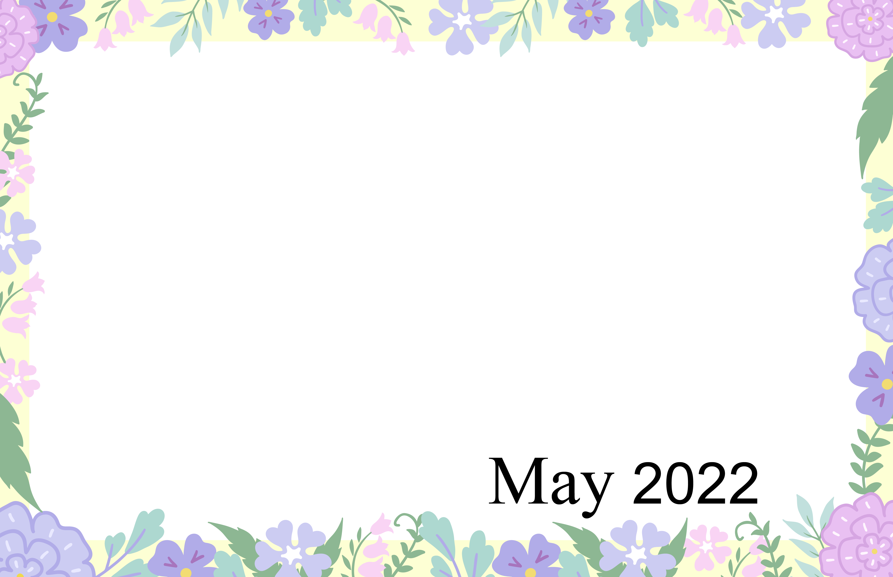
ASHLEY WOODS CALENDAR OF EVENTS ARE SUBJECT TO CHANGE; ANY QUESTIONS CONTACT Kim Bidleman at 546.8439 x6504 OR Ally Cass x6514
Sunday | Monday | Tuesday | Wednesday | Thursday | Friday | Saturday
1  May Day | 2 | 3 | 4 | 5  Cinco de Mayo | 6 | 7
8  Mother’s Day | 9 | 10 | 11 | 12 | 13 | 14
15 | 16 | 17 | 18 | 19 | 20 | 21  Armed Forces Day
22 | 23  Victoria Day (Canada) | 24 | 25 | 26 | 27 | 28
29 | 30  Memorial Day | 31

