The Episcopal Church Home, Recreation Calendar

January 13th – 19th 2025



Monday, January 13th, 2025
9:30 Hairdresser Day – 4 North
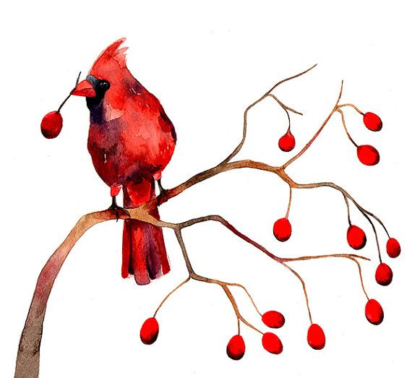
10:30 Mixed Up Word Challenge - South Hall 2
10:30 Famous Faces - 4 North
1:30 Friendly Visits, One to One - South Hall 1
2:15 Tabletop Bowling - 2 North
2:15 Music Time - 4 North
2:30 Weekly Music Hour: Etta James - 3 North

Tuesday, January 14th, 2025
9:30 Hairdresser Day – South Hall 1 & 2
10:30 Word Games - 2 North
10:30 Junk Drawer Detective: Wintertime - South Hall 1
10:30 Game Time - 4 North
2:00 Music Therapy – 2 North
2:15 Funny Basketball: The Harlem Globetrotters & More - 3 North
2:15 Music Corner: Franz Schubert - 4 North

2:30 Hot Chocolate & Winter Songs - South Hall 2

Wednesday, January 15th, 2025
9:30 Hairdresser Day – 3 North
10:30 Worship Service – Chapel

2:15 Crafty Corner - South Hall 2
2:15 BINGO - 2 North
2:15 “The Greatest” Heavyweight Boxer: Muhammad Ali - 3 North
2:15 Hymn Sing - 4 North

4:30 Friendly Visits with Chara - 4 North

Thursday, January 16th, 2025
9:30 Hairdresser Day – 2 North
10:30 * Book Club Group* – Back of Dining Room - 2 North & South Hall 2
10:30 Reminisce: Alice in Wonderland - 3 North
10:30 Reminisce Corner: Alice in Wonderland - 4 North
2:15 *Queen of Hearts Tea Party* – Main Dining Room

Friday, January 17th, 2025
10:30 BINGO - South Hall 2
10:30 Weekly Music Hour: Etta James - South Hall 1
10:30 Trivia Corner: Famous January Birthdays - 4 North
2:15 Music Time - 2 North

2:15 Music Time - 3 North
2:15 Music Visits (Room to Room) - North

Saturday, January 18th, 2025
9:15 Individual/Small Group Visits - 3 North
10:30 Coffee Talk - South Hall 2
1:30 Individual/Small Group Visits - 4 North
2:45 Coffee Talk - 2 North

Sunday, January 19th, 2025
2:15 Sunday Movie Matinee – All Units

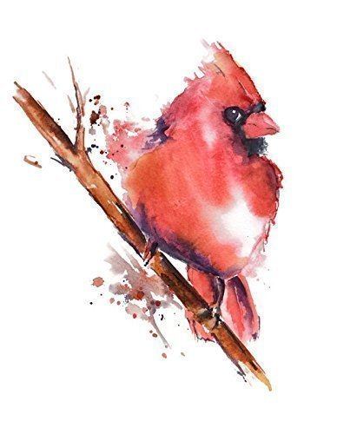


Questions/Comments?
Contact The Recreation Department at (585) 546 – 8439 x 3155 or 3137
Programs are Subject to Potential Change or Alteration
* = Select resident attendees

